William Thing

CSE 414

Homework 6

1. E/R Diagram below and attached in file (if hard to read).

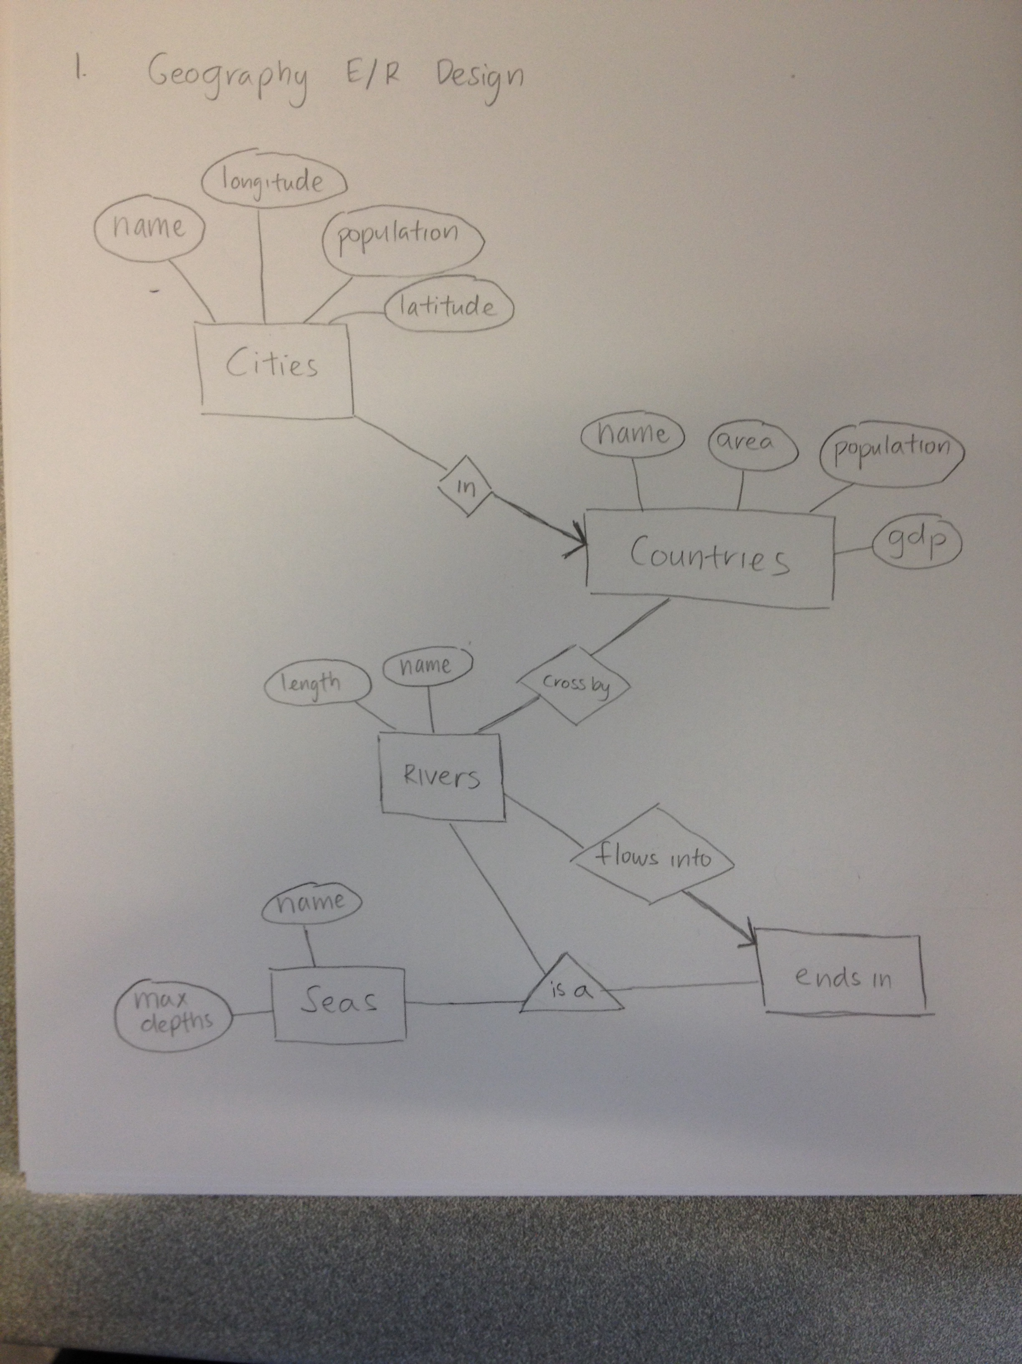

2.

a) CREATE TABLE **InsuranceCo**(name VARCHAR(30) PRIMARY KEY, phone VARCHAR(10));

CREATE TABLE **Person**(name VARCHAR(30), ssn VARCHAR(9) PRIMARY KEY);

CREATE TABLE **Driver**(licenceNo VARCHAR(12) PRIMARY KEY, ssn VARCHAR(9) REFERENCES Person);

CREATE TABLE **NonProfessionalDriver**(licenceNo VARCHAR(12) PRIMARY KEY, FOREIGN KEY (licenceNo) REFERENCES Driver);

CREATE TABLE **ProfessionalDriver**(licenceNo VARCHAR(12) PRIMARY KEY, medicalHistory VARCHAR(200), FOREIGN KEY (licenceNo) REFERENCES Driver);

CREATE TABLE **Vehicle**(licencePlate VARCHAR(10) PRIMARY KEY, year INT, maxLiability INT, maxLossDamage INT, name VARCHAR(20) REFERENCES InsuranceCo, ssn VARCHAR(9) REFERENCES Person);

CREATE TABLE **Car**(licencePlate VARCHAR(10) PRIMARY KEY, make VARCHAR(20), FOREIGN KEY (licencePlate) REFERENCES Vehicle);

CREATE TABLE **Truck**(licencePlate VARCHAR(10) PRIMARY KEY, capacity INT, licenceNo VARCHAR(12) REFERENCES ProfessionalDriver, FOREIGN KEY (licencePlate) REFERENCES Vehicle);

CREATE TABLE **drives**(licenceNo VARCHAR(12) REFERENCES NonProfessionalDriver, licencePlate VARCHAR(10) REFERENCES Vehicle, PRIMARY KEY (licenceNo, licencePlate));

b) In my relational schema, Vehicles represents “insures” because we do not need to make a separate relation for “insures” in the E/R diagram. Which is why I j included it in my Vehicles relation.

c) The operates represents a ‘many-to-one relationship’ when drives represents a ‘many-to-many relationship’.